Name: ______________________ Date: _________________
Year 6 Food Preparation and Nutrition
Healthy eating: Packed lunch project.
Tasks:
- Label the main sections of the eatwell guide.
- State three food examples for each section.
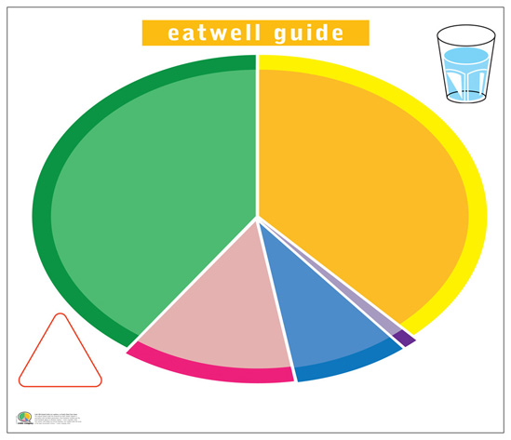
Name of section:

Three food examples
- _________________________
- _________________________
- _________________________
Name of section:

Three food examples
- _________________________
- _________________________
- _________________________
Name of section:

Three food examples
- _________________________
- _________________________
- _________________________
Name of section:

Three food examples
- _________________________
- _________________________
- _________________________
Name of section:

Three food examples
- _________________________
- _________________________
- _________________________
Use this website: https://www.nhs.uk/live-well/eat-well/the-eatwell-guide/
Research the eight tips for healthy eating. Remember to be specific.
1._______________________________________________________________
2. _______________________________________________________________
3. _______________________________________________________________
4. _______________________________________________________________
5. _______________________________________________________________
6. _______________________________________________________________
7. _______________________________________________________________
8. _______________________________________________________________
Question:
Which food should you try to avoid? (2 marks)

Why? _____________________________________________________________

_____________________________________________________________

_____________________________________________________________

_____________________________________________________________ (2 marks)
As you make the move to secondary school, it’s time for you to take increasing responsibility for the foods you eat.

You may choose to take a packed lunch or select foods from the school canteen.

https://youtu.be/1tJYcNt6Bpk
Now set yourself FIVE golden rules you are going to follow for your packed lunch:
1._______________________________________________________________
2. _______________________________________________________________
3. _______________________________________________________________
4. _______________________________________________________________
5. _______________________________________________________________
Research and explain: Why are wise food choices so important?
Stretch
and challenge
__________________________________________________
__________________________________________________
__________________________________________________________________
__________________________________________________________________
__________________________________________________________________
__________________________________________________________________
__________________________________________________________________
__________________________________________________________________
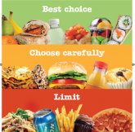
You can use the template below or devise your own to present your healthy packed lunch. It is important that you clearly label your work with:
- Name of food
- Section of the eatwell guide
- How it meets the eight tips for healthy eating?
- The health benefits of your food choices.

Peer assessment:
WWW:_ ___________________________________________________________
__________________________________________________________________
EBI: ______________________________________________________________
__________________________________________________________________
Calculate the nutritional content of your packed lunch use:
Stretch
and challenge
http://explorefood.foodafactoflife.org.uk
To produce a professional label like this one.
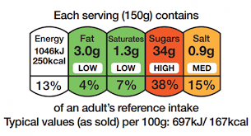

- Click on the icon calculate recipe.
- Enter the name of your product.
- Type in the foods/ingredients – keep them simple e.g. just type in cheese and search for cheddar. (use the side bar to scroll down – ingredients listed alphabetically.)
- Add in amount.
- When all ingredients have been entered – click – view summary.
- Enter the number of portions.
- Click calculate.
There are guidelines to tell you if a food is high in fat, saturated fat, salt, sugar or not.
Total fat
High: more than 17.5g of fat per 100g
Low: 3g of fat or less per 100g
Saturated fat
High: more than 5g of fat per 100g
Low: 1.5g of fat or less per 100g
Sugars
High: more than 22.5g of total sugars per 100g
Low: 5g of total sugars or less per 100g
Salt
High: more than 1.5g of salt per 100g (or 0.6g sodium)
Low: 0.3g of salt or less per 100g (or 0.1g sodium)

- Click create label.
- Enter product name.
- Print screen using: Fn F11
- Open a word document ctrl V.
- Crop image.

Add your label here.

Now comment on how well your packed lunch meets your needs, refer back to the healthy eating guidelines and the guidelines above.
(You will need to do this on lined paper.)
Homework:
To make your ideal packed lunch at home and if a parent, grandparent, carer or teacher is able to email me a photograph, it would be lovely to see your pack lunches! - my email address is:
scrossley@bolsover.derbyshire.sch.uk

